**11. Create a React Application “eventexamplesapp” to handle various events of the form elements in HTML.**

**EventApp.js**

import React, { useState } from "react";

function EventApp() {

  const [count, setCount] = useState(0);

  const sayHello = () => {

    alert("Hello! Member1");

  };

  const increment = () => {

    setCount(prev => prev + 1);

    sayHello();

  };

  const decrement = () => setCount(prev => prev - 1);

  const sayWelcome = (msg) => {

    alert(msg);

  };

  const handleClick = () => {

    alert("I was clicked");

  };

  return (

    <div style={{padding: 30}}>

      <div>{count}</div>

      <button onClick={increment}>Increment</button> <br/>

      <button onClick={decrement}>Decrement</button><br/>

      <button onClick={() => sayWelcome("welcome")}>Say welcome</button><br/>

      <button onClick={handleClick}>Click on me</button><hr />

      <CurrencyConvertor />

    </div> ); }

function CurrencyConvertor() {

  const [amount, setAmount] = useState("");

  const [currency, setCurrency] = useState("");

  const handleSubmit = (e) => {

    e.preventDefault();

    let result = 0;

    let message = "";

    if (currency.toLowerCase() === "euro") {

      result = Number(amount) * 80;

      message = `Converting to Euro Amount is ${result}`;

    } else {

      message = "Please enter Euro as currency (for demo)";

    }

    alert(message);

  };

  return (

    <div>

      <h1 style={{color: "green", fontWeight: "bold"}}>Currency Convertor!!!</h1>

      <form onSubmit={handleSubmit}>

        <div>

          <label>Amount: </label>

          <input

            type="number"

            value={amount}

            onChange={e => setAmount(e.target.value)}

            required

          />

        </div>

        <div>

          <label>Currency: </label>

          <textarea

            value={currency}

            onChange={e => setCurrency(e.target.value)}

            required

          />

        </div>

        <button type="submit">Submit</button>

      </form>

    </div>

  );

}

export default EventApp;

**Output:**

**Increment:**

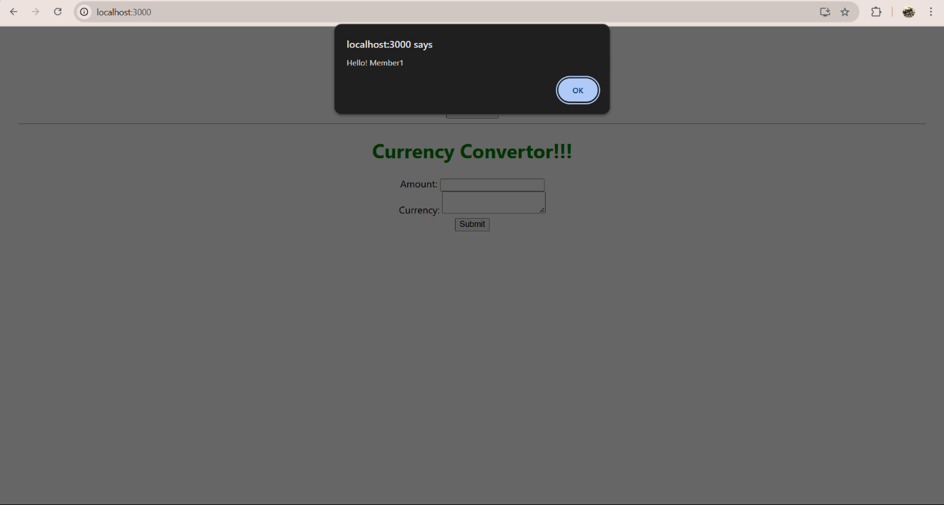

**Welcome:**

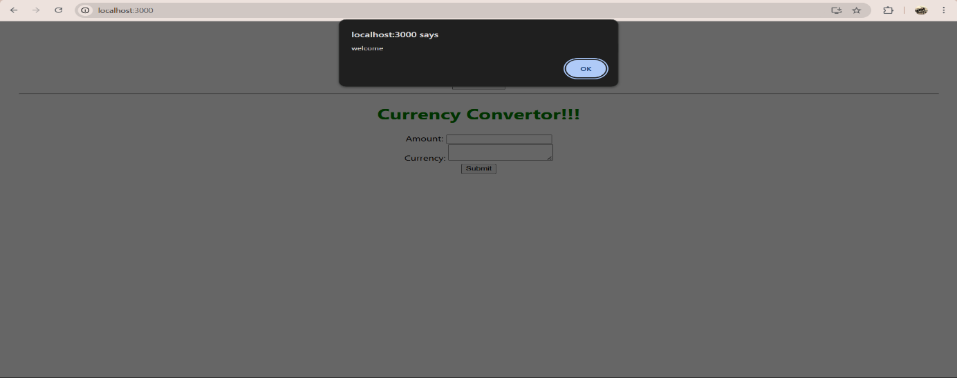

**Hello:**

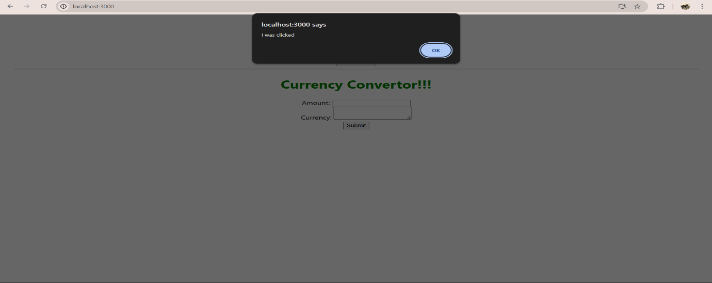

**Convert:**

